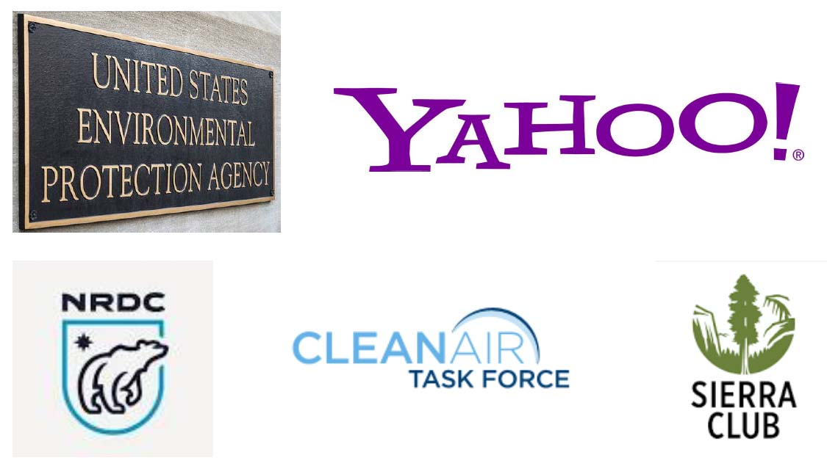

EX PARTE COMMUNICATIONS & OUTSOURCING EPA’S “AGENCY EXPERTISE”: THE CASE FOR VACATING EPA’s GHG RULES DUE TO AN INCOMPLETE DOCKET & ABANDONMENT OF ANY PRESUMPTION OF EXPERTISE OR IMPARTIALITY (“CHEVRON” DEFERENCE)

Emails Obtained under the FOIA by the Energy & Environment Legal Institute, with additional emails obtained by the Competitive Enterprise Institute and Jeb Harmon

Prepared by Christopher C. Horner
for the Energy & Environment Legal Institute
February 22, 2016

